Digitalized Format for Self Appraisal Report
Year of Appraisal: 2009-10

Profile of the Teacher Education Institution

- Name of the institution : Govt. College of Education, Patiala

- Address for communication Govt. College of Education, Patiala- 147004
- Phone No. (with STD Code) : 0175-2217587

- Fax No. : 0175-2302002

- E-mail : gcepta_govt@yahoo.com

- Date of establishment of the institution: 1955

- Course(s) offered
:
1 | 2 | 3 | 4 | 5
Name of the course in full | Stage/level | Duration | Year of starting the course | Intake approved
Master of Education (M.Ed) | Post Graduation | One Year | 1956 | 25
Bachelor of Education | Graduation | One Year | 1956 | 200
Elementary Teacher Training (ETT) | Secondary | Two Years | To start in 2011 | 50

- Name of the University/Examining Body to which the institution is affiliated :
Punjabi University, Patiala.

- Number and date of the order of the Regional Committee granting recognition/Permission(coursewise):
M.Ed-PB- 6/M.Ed/200/3795 dated- 26-06-2000

B.Ed- F.3PB-15/B.Ed/2000/5096 dated- 20-07-2000

ETT- F.NRC/NCTE/F73/PB-435/26265-71 dated-27-
08-2007

- Mode of selection of candidates :
 |  | Yes | No
 | Centralized test at the state level for B.Ed | Yes
 | Test conducted by the university for M.Ed | Yes
 | Test conducted by the institution
 | Test conducted by an independent agency
 | Based on marks obtained in the qualifying examination
 | By the management

- Criteria for admission :
 |  | Yes | No
 | As per NCTE norms | Yes
 | Norms superior to NCTE
 | In relaxation of NCTE norms with respect to minimum percentage of marks
 | In relaxation of NCTE norms with respect to qualifying course
 | In relaxation of special eligibility provisions of NCTE norms such as participation in national/regional/state/university level events
 | In relaxation of professional experience
 | In relaxation of professional experience and performance in qualifying course

- Academic calendar of the outgoing academic session

 |  | D | D | M | M | Y | Y
 | Start of admission B.Ed  M.Ed | 1  1 | 7  2 | 0  1 | 8  0 | 0  0 | 9  9
 |  | D | D | M | M | Y | Y
 | Closure of admission B.Ed  M.Ed | 0  0 | 5  5 | 1  1 | 0  1 | 0  0 | 9  9
 |  | D | D | M | M | Y | Y
 | Start of teaching B.Ed  M.Ed | 0  1 | 1  9 | 0  1 | 9  0 | 0  0 | 9  9
 |  | D | D | M | M | Y | Y
 | Last teaching day | 2 | 6 | 0 | 5 | 1 | 0
 | Number of teaching days |  |  |  | 2 | 0 | 3
 | Number of days of vacation/break during the academic session |  |  |  | 0 | 1 | 9
- Practice Teaching at School

(a) | Total number of practicing teaching days | 4 | 0

(b) | Minimum number of practice teaching lessons given by each student | 5 | 0
- Pre-practice teaching at the institution

(a) | Number of pre-practice teaching days  (simulated/micro-teaching/any other) | 1 | 1
(b) | Minimum number of pre-practice teaching lessons given by each student | 1 | 2
(c) | Total number of demonstration lessons held | 0 | 4

- Examinations

 | Number of sessional tests held for each paper |  |  |  |  |  | 1
Number of class tests held for each paper 1
 | Number of assignments for each paper |  |  |  |  | 0 | 2
 |  | D | D | M | M | Y | Y
 | Date of commencement of annual examination B.Ed- Theory  Practical  M.Ed- Theory  Practical | 0  0  1  1 | 92  0  6 | 000  0 | 68  6  8 | 111  1 | 0  0  0  0
 |  | D | D | M | M | Y | Y
 | Date of declaration of result B.Ed  M.Ed | 1  2 | 7  7 | 0  0 | 9  9 | 1  1 | 0  0
 |  | D | D | M | M | Y | Y
 | Date of submission of dissertation  (Post-graduate course) | 2 | 8 | 0 | 8 | 1 | 0

- Scheme of examination
Yes No
 | External examination only
 | Internal and external examinations | Yes
 | Internal examination only

- Student support and progression

 | Number of students who appeared in the final examination | 2 |  | 2 |  | 0
 | Number of students who passed in the examination | 2 | 2 |  | 0
 | Number of students who (failed)reapear in the examination | 0 | 0 |  | 0
 | Number of students who joined higher studies | 0 | 6 |  | 1
 | Number of students who took up teaching employment | 0 | 9 |  | 7
 | Number of students who secured employment through the institution | 0 |  | 0 |  | 5

- Teaching Resources
 |  | Yes |  | No
 | Principal/Head of the Department is in position | Yes
 | Number of teachers employed on full-time basis |  | 1 |  | 8
 | Number of teachers employed on part time basis |  | 0 |  | 0
 | Number of Guest lecturers engaged |  | 0 |  | 3
 | Number of teachers on regular scale of pay |  | 1 |  | 8
 | Number of teachers on consolidated remuneration |  | 0 |  | 3
 | Number of teachers with qualifications as per NCTE norms |  | 2 |  | 1
 | Number of teachers yet to qualify NET/SLET |  | 0 |  | 0
 | Number of teachers yet to obtain post-graduate degree in education |  | 0 |  | 2
 | Number of teachers without school experience |  | 0 |  | 0

- Professional Development of Teachers

 | Number of teachers who attended in-service courses during the preceding year |  | 0 | 0
 | Number of teachers enrolled in part-time post-graduate course in education (M.Ed./M.A.(Education)/M.Phil) |  | 0 | 0
 | Number of teachers enrolled in full-time post-graduate course in education (M.Ed./M.A.(Education)/M.Phil) |  | 0 | 0
 | Number of teachers enrolled in Ph.D. programme |  | 0 | 1
 | Number of teachers who participated in seminars/conferences/ workshops |  | 2 | 1
 | Number of papers published by the teachers Books Published |  | 1 | 1
 | Number of teachers who received professional recognition/ awards |  | 0 | 1

- Land and Building

 |  | Yes | No
 | Institution functions from its own building | Yes
 | Institution functions from a rented building |  | No
 | Institution building is under construction |  | No
 | Institution building is shared for running another course(s) |  | No
 | Title of the land is on free-hold ownership basis | Yes
 | Title of the land is on long-lease as per law |  | No

21. Educational Technology

 | Number of computers with supporting accessories |  |  | 4 |  |  | 1
 |  | Yes |  |  |  | No
 | Access to Internet | Yes
 | Number of hands - on experience hours provided to each student per week |  |  | 0 |  |  | 3
 | Number of education related CD-ROMs available |  | 1 |  | 7 |  | 4
 | Number of education related video-cassettes available |  |  |  | 6 |  | 5
 | Number of education related audio-cassettes available |  |  |  | 1 |  | 0
 |  | Yes |  |  |  | No
 | Website of the institution | Yes
 | Availability of LCD projector | Yes
 | Availability of OHP | Yes
 | Availability of TV | Yes
 | Availability of VCR | Yes
 | Availability of public-address system | Yes

- Library resources

 | Number of books in the library | 3 | 7 | 5 |  | 7 | 5
 | Number of books added to the library during the preceding year |  |  | 3 | 2 |  | 5
 | Total Number of educational journals/periodicals being subscribed |  |  |  |  | 2 |  | 0
 | Number of encyclopedia available in the library |  |  |  |  | 4 |  | 2
 | Number of books available in the reference section of the library |  | 1 | 9 | 7 |  | 6
 | Total seating capacity in the library |  |  |  | 5 |  | 5
- Sports and Physical Education Resources

Institution has |  | Yes | No
 | Playground (football/hockey etc.) | Yes
 | Playground (football/hockey etc.) of another institution on sharing basis | Yes
 | Gymnasium/Multipurpose hall | Yes
 | Facilities for gymnasium | Yes
 | Facilities for athletics | Yes
 | Facilities for Health Education | Yes
 | Facilities for Anatomy Lab |  | No
 | Facilities for Physiology Lab |  | No

Organization and Management

 |  |  | Yes | No
24. | Institution is
 | (a) | Government owned | Yes
 |  | Aided |  | No
 |  | Unaided |  | No
 |  | University Department |  | No

25. |  | Minimum emoluments (basic pay and allowances) paid to teachers on regular appointment is | 3 | 5 | 0 | 6 | 0
 |  | Minimum emoluments (basic pay and allowances) paid to teachers on adhoc service is
 |  | Minimum consolidated remuneration paid to teachers is
 |  | Per lecture per hour honorarium paid to guest lecturers is |  |  | 1 | 7 | 5

 |  |  |  | Yes | No
26. |  |  | Salaries are paid in cash |  | No
 |  |  | Salaries are paid through account payee cheque | Yes

 |  |  |  | Yes | No
27. |  |  | Salaries are disbursed each month | Yes
 |  |  | Teachers are paid salary for the vacation period | Yes

Expenditure and Receipts

28. |  | Salaries paid to teaching staff during the preceding financial year | 1 | 2 | 5 | 2 | 9 | 0 | 9 | 9
 |  | Salaries paid to non-teaching staff during the preceding financial year |  | 4 | 9 | 1 | 0 | 1 | 6 | 4
 |  | Amount spent on utilities during the preceding financial year |  | 1 | 5 | 5 | 2 | 9 | 7 | 7
 |  | Amount spent on purchase of books and journals for the library during the preceding financial year |  |  |  | 2 | 6 | 2 | 0 | 2
 |  | Amount spent on purchase of equipment during the preceding financial year
 |  | Amount spent on purchase of furniture during the preceding financial year
 |  | Amount spent on capital expenditure during the preceding financial year
 |  | Amount spent on contingencies during the preceding financial year |  |  | 1 | 3 | 3 | 6 | 6 | 5

29. |  | Amount carried forward from the previous financial year |  | 5 | 3 | 1 |  | 3 | 9 | 6 | 3
 |  | Receipts from fees (tuition and all other fees) during the preceding financial year |  |  | 6 |  | 3 | 3 | 1 | 5 | 0
 |  | Receipts from PTA/donation during the preceding financial year |  | 1 | 5 |  | 7 | 2 | 5 | 3 | 0
 |  | Receipts from consultancies and extension programmes during the preceding financial year
 |  | Amount of grants received from the governments during the preceding financial year | 1 | 8 | 0 |  | 5 | 3 | 2 | 5 | 0
 |  | Income from investments during the preceding financial year

 |  |  |  |  |  |  |  |  | Yes |  |  | No
30. | Excess of expenditure over income |  |  |  |  |  |  |  |  |  |  | No
 | Amount of excess expenditure over income.
31. | The institutional accounts of the preceding financial year have been audited  PTA |  |  |  |  |  |  |  |  |  |  | No
31.
  Yes

Endowment fund and Reserve Fund (For ETT – Self financing course)

32. |  |  | Amount of Endowment fund |  |  | 5 | 0 | 0 |  | 0 | 0 |  | 0
 |  |  | Amount of Reserve fund |  |  | 3 | 0 | 0 |  | 0 | 0 |  | 0
 |  |  |  |  |  |  |  |  | Yes |  |  | No
 |  |  | Endowment fund is maintained jointly with NCTE |  |  |  |  |  |  |  |  | No

- Resume of the institution

Brief appraisal of the overall performance of the institution during the preceding academic session and plans for future development may be given.

(i) The institute has got approval letter from NCTE to start ETT course. NCTE has been requested to open the joint account to enable the college to start admission of ETT.
(ii) During the session 2009-10 computer education was made compulsory for all students.
(iii) In the examination conducted by Punjabi University, Patiala for the session 2009-10 first four positions of the university was secured by the student of M.Ed.

(iv) College intends to start ETT classes from the session 2011-2012 after the permanent approval by NRC, NCTE, Jaipur.

(Signature of the Head of the Institution/Principal)

List of documents

- Academic calendar of activities of the preceding session.
- Copy of time-table of the preceding sessions.
- Staff profile (Proforma-1)
- List of practicing school
- Details of fee structure (proforma2)
- Details of salary disbursement (proforma 3)
- Copies of FDRs towards maintenance of Endowment and Reserve funds
Note : All the documents are to be signed by the Principal / Management.

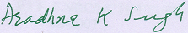

(Signature of the Head of the Institution/Principal)
Principal
Govt. College of Education
Patiala
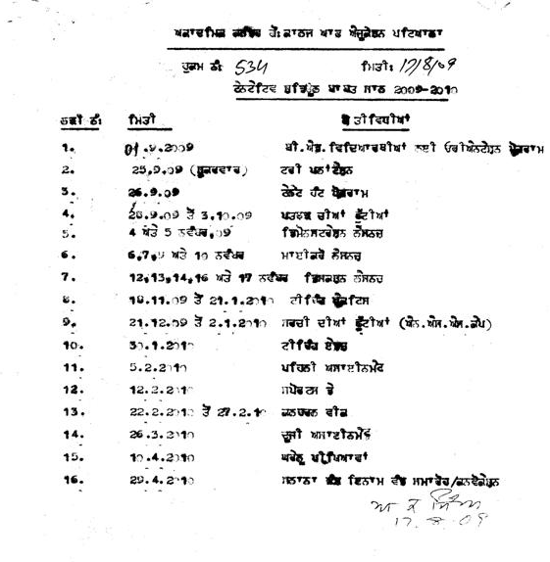

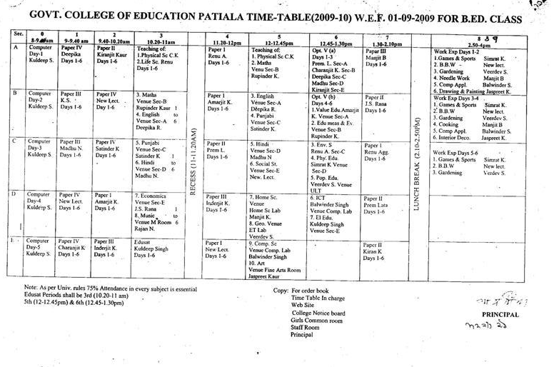

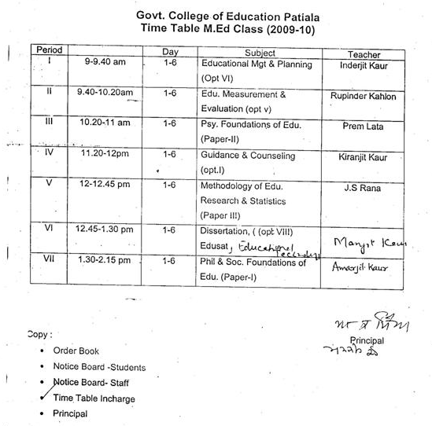

Staff Profile
Name of the Institution: Govt College of Education, Patiala
Course: M.Ed & B.Ed
Address of e Institution: Govt College of Education, Patiala- 147004

Sr No | Name & Designation | Date of Birth | Qualifications |  |  |  | Years of Experience in a recognized Secondary/ Senior Secondary School | Teaching Experience in a Elementary/ Secondary teacher education institution from_______  to__________ | Date of appointment in the present position | Mode of appointment (full time on regular basis/part time basis) Date of selection committee meeting | Photograph
 |  |  | General Qualifi. | Division/Percentage of marks | Professional Qualification | Division/Percentage of marks
 |  |  | Bachelor Degree Post Graduate Degree |  | B.Ed M.Ed M.Phil Ph.D NET/SLET
01 | Principal | Aradhna K Singh | B.Sc.  M.Sc (Chem) | I/70.00  I/67.30 | M.Phil. | I/77.50 | 25 Years (Sr. Sec. Classes) | Above  34 Years | 30.9.2005 as Principal  4.8.1976 as a Lecturer | Full time on regular basis by state govt | 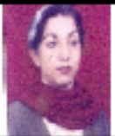
02 | Rajan Narula Asso. Prof. Teaching of Music | 12-12-1954 | B.A.  M.A. (Music) | I/ 68  I/ 70 | B.Ed | II/ 57 | NA | 31-08-1991 Still working | 25-09-1982 | Full time on regular basis by state govt | 
03 | Manjit Kaur Asso. Prof. Teaching of Home Science | 28-09-1959 | B.Sc. M.Sc. | II/ 59 I/ 70.40 | B.Ed M.Ed Ph.D(Edu) | I/ 65 II/ 52 Awarded | NA | 07-12-1985 Still working | 07-12-1985 | Full time on regular basis by state govt | 
04 | Renu Aggarwal Asso. Prof. Teaching of Life Science | 12-02-1958 | B.Sc.  M.Sc | I/ 74.80 I/ 71.30 | B.Ed  M.Ed  M.Phil  Ph.D(Zoology) | I/ 68.30 I/ 64.90 Grade-A  Awarded | NA | 08-09-1993 to 02-08-2000 & 24-06-2005 Still working | 18-09-1986  (Adhoc) 14-11-1987  (Regular) | Full time on regular basis by state govt | 
05 | Amarjit Kaur Asso. Prof. Philosophy | 20-06-1957 | B.A.  M.A.(Philosophy) | I/ 61.00 I/ 62.00 | B.Ed  M.Ed  M.Litt  Ph.D | I/ 67.00 I/ 63.00 Grade-O Awarded | NA | 20-08-1993 Still working | 25-01-1988 | Full time on regular basis by state govt | 
06 | Joginder Singh Rana  Asso. Prof. Teaching of Economics | 01-04-1954 | B.A.  M.A. | I/ 64.30 I/ 62.00 | B.Ed  M.Ed  Ph.D(Edu) | II/54.70 I/ 62.00  Awarded | NA | 02-08-1989 Still working | 21-08-1986 | Full time on regular basis by state govt | 
07 | Simrat Kaur Asso. Prof. Physical Education | 06-01-1965 | D.P.Ed  B.A  M.P.Ed | I/ 72.00 I/ 66.00 I/ 74.00 | Ph.D  (Physical Edu) | Awarded | NA | 01-04-1998 | 13-08-1986 (Adhoc)  16-11-1987  (Regular) | Full time on regular basis by state govt | 
08 | Rupinder Kaur Kahlon  Asso. Prof. Teaching of Mathematics | 12-04-1957 | B.A.  M.Sc. | II/ 54.46  I/ 61.75 | B.Ed M.Ed M.Phil  Ph.D(Edu) | I/ 62.40 II/ 52.80  I/ 74.60 Awarded | NA | 02-02-1993 | 14-03-1988 | Full time on regular basis by state govt | 
09 | Veerdev Singh Asso. Prof. Teaching of Social Studies | 09-02-1962 | B.A. M.Sc.(Geog.) | I/ 63.00 I/ 63.00 | B.Ed M.Ed M.Phil | II/ 51.00 I/ 61.00 Grade-B+ | 1Year 11Months | 12-10-1996 Still working | 01-10-1993 | Full time on regular basis by state govt | 
10 | Kiranjit Kaur Asso. Prof. Psychology | 27-10-1965 | B.A.  M.A. | I/ 64.00 I/ 66.00 | B.Ed  M.Ed  M.Phil | I/ 62.00 II/ 51.00  Grade-A | NA | 08-08-1992 | 08-08-1992 | Full time on regular basis by state govt | 
11 | Prem Lata Asso. Prof. Psychology | 25-03-1959 | B.A.  M.A. | I/ 64.33 I/ 55.00 | B.Ed M.Ed  M.Phil  Ph.D(Psy) | I/ 60.00 I/ 55.00 I/ 69.00 Awarded | NA | 05-07-1999 Still working | 30-07-1993 | Full time on regular basis by state govt | 
12 | Charanjit Kaur Asso. Prof. Teaching of Physical Science | 06-02-1966 | B.Sc.  M.Sc. | I/ 74.61 I/ 55.41 | B.Ed M.Ed M.Phil | II/52.22  I/ 65.66 Grade-B+ | NA | Still working 2003 | 08-09-1993 | Full time on regular basis by state govt | 
13 | Jaspreet Kaur Dhillon  Sr. Lecturer in Fine Art | 15.10.1966 | B.A.  M.A. | I/69.38  82.5 | Ph.D. | Awarded |  | 29.7.2000  Still Working | 29.12.1994 | Full time on regular basis by state govt | 
14 | Deepika Lamba  Asso. Prof. Teaching of English | 09-02-1966 | B.A.  M.A | I/ 68  I/ 4.43/6.0GPA | B.Ed M.Ed M.Phil | I/ 62.00 I/ 61.00 I/ 62.00 | NA | 01-07-1998 Still working | 16-08-1995 | Full time on regular basis by state govt | 
15 | Inderjit Kaur Asso. Prof. Education | 15-09-1957 | B.A.  M.A(Edu) | II/ 54.9  I/ 62.30 | M.Phil  Ph.D | Grade-A Awarded | NA | 13-08-1986 Still working | 13-08-1986  (Adhoc) 05-10-1995  (Regular) | Full time on regular basis by state govt | 
16 | Madhu Narula Asso. Prof. Teaching of Hindi | 15-04-1960 | B.A.  M.A. | II/ 58.0 I/ 60.00 | B.Ed  M.Ed  M.Phil | II/ 58.0 II/ 52.0 Grade-A | NA | ----------1995 Still working | 23-09-1986  (Adhoc) ---08-1995  (Regular) | Full time on regular basis by state govt | 
17 | Satinder Kaur Asso. Prof. Teaching of Punjabi | 25-07-1961 | B.A.  M.A. | II/ 56.6 I/ 60.00 | B.Ed M.Ed M.Phil | I/ 60.00 I/ 60.00 Grade-A | NA | 01-08-2000 Still working | 10-05-1996 | Full time on regular basis by state govt | 
18 | Balwinder Singh  Asso. Prof. Computer Science | 05-05-1964 | B.Sc.  M.Sc(Maths) MCA | I/ 69.07 I/ 73.10 I/ 67.20 |  |  | 2.5 Years | 16-12-1996 Still working | 16-12-1996 | Full time on regular basis by state govt | 
19 | Kuldeep Singh Science Master | 14-11-1961 | B.Com  M.Com | II/ 51.2 III/ 46.0 | B.Ed M.Ed | II/ 54.0 I/ 60.0 | 19 Years | 04-02-2006 Still working | 19-11-1987 | Full time on regular basis by state govt | 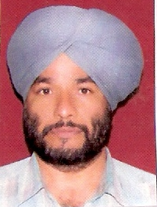
20 | Devinder Kaur Instructor  Guest Faculty | 22-01-1963 | M.A(Fine Arts)  M.A (Folk Art) | I/ 60.37  I/ 61.00 | B.Ed  Ph.D | II/57.0  Awarded | NA | 07-09-1998 to  19-12-1998(3  months);Degree  College 23-08-2004 to 31-03-  2007(3 years) | 12-09-2007 10-09-2007  Sep 2009 to 31-5-2010 | Part time basis | 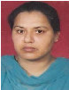
21 | Parmjit Kaur  Guest Faculty | 19/01/1976 | BA  MA | II/53  II/59 | B.Ed  M.Ed  Ph.D. | II/50  I/60.1  Awarded |  | 02-09-2008 |  | Part Time Basis | 
22 | Assistant Professor in Education | Post Vacant

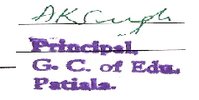
Signature of Principal/Head______________________
Name: Aradhna K. Singh
Stamp of Institution ____________________________

List of Practicing Schools (2009-2010)

S.No. | Name of The School
1 | Govt. Model Sr. Sec. School, Civil Lines, Patiala
2 | Govt. Multipurpose Sr. Sec. School, Patiala
3 | Govt. Girls Multipurpose Sr. Sec. School, New Power House Colony, Patiala
4 | Govt. Model Sr. Sec. School, Civil Lines, Patiala
5 | Govt. Model Sr. Sec. School, Pheelkhana, Patiala
6 | Govt.(Co-ed) Sr. Sec. School, Tripuri, Patiala
7 | B.N. Khalsa Sr. Sec. School Bus Stand Patiala
8 | B.N. Khalsa Sr. Sec. School, Sirhind Road, Patiala
9 | Modern Sr. Sec. School, Patiala
10 | Veer Haqikat Rai Model Sr. Sec. School, Patiala
11 | S.D.K.S. Skuntla Hr. Sec. School, Patiala



